Supporting Information for
Future Heat-Stress During Muslim Pilgrimage (Hajj) Projected to Reach “Extreme Danger” Levels

SuChul KANG, Jeremy S PAL and Elfatih A B ELTAHIR

Contents of this file
- Supplementary Text1
- table S1. Dates of Hajj used in this study for the period 1976-2100.
- fig. S1. Daily maximum temperature during Hajj.
- fig. S2. Monthly mean seasonal cycle of surface variables over Mecca.
- fig. S3. Spatial distribution for sea surface temperature (shading) and surface wind (vector).
- fig. S4. Spatial distribution for surface specific humidity (shading) and surface wind (vector).
- fig. S5. Wind rose diagrams for 6-hourly surface (10m) winds.
- fig. S6. Monthly seasonal climatology.
- fig. S7. Maps of ERA-Interim reanalysis average a) sea surface temperature seasonal change (August-September minus May-June) (shading) and surface winds (vectors) for the period 1979-2017 and b) surface specific humidity seasonal change and surface winds.
- fig. S8. Table of wet-bulb temperature generated from temperature and relative humidity.

Supplementary Text1
1. Seasonal characteristics during August-September-October over Mecca

The highest mean monthly surface temperatures in Mecca occur from May through September. The highest specific humidity and wet-bulb temperature conditions, however, prevail in the late summer and early fall from August through October (Fig S2). Specific humidity over Mecca is largely influenced by the combination of evaporation associated with sea surface temperature (SST) of the Red Sea and moisture transport associated with seasonal wind flow over Central Red Sea. The spatial patterns of SST and specific humidity during summer (July-August–September) and winter (December–February) differ substantially in response to seasonally varying solar forcing and surface wind through heat fluxes (Abualnaia et al., 2015) over the Red Sea (Figs S3 and S4). Over the central Red Sea, SST and specific humidity begin to increase in March achieve a maximum value in August (Fig S6c-d).
There are two seasonal wind systems over Red sea: 1) the prevailing northwesterly winds originating from eastern Mediterranean weather systems; and 2) southerly winds associated with the Indian monsoon. From September through October, a low pressure system shifts from the continent to the Arabian Sea and results in a high pressure over the land. This change in the pressure system causes a shift in the direction of the Indian monsoon winds from northwest to southeast (Figs S3 and S4). As a result, westerly and northwesterly winds are dominant over the central Red Sea and Mecca from August through October (Fig S5 and S6b). The resulting seasonal variations of wind flow and SST create convergence zones over the middle of the Red Sea, which in turn favors the development of humid air conditions over Mecca (Figs S6 and S7).

Reference
Abualnaja, Y., et al. (2015). Impacts of climate modes on air-sea heat exchange in the Red Sea. J. Clim., 28, 2665–2681. https://doi.org/10.1175/JCLI-D-14-00379.1

Table S1. Dates of Hajj used in this study for the period 1976-2100.
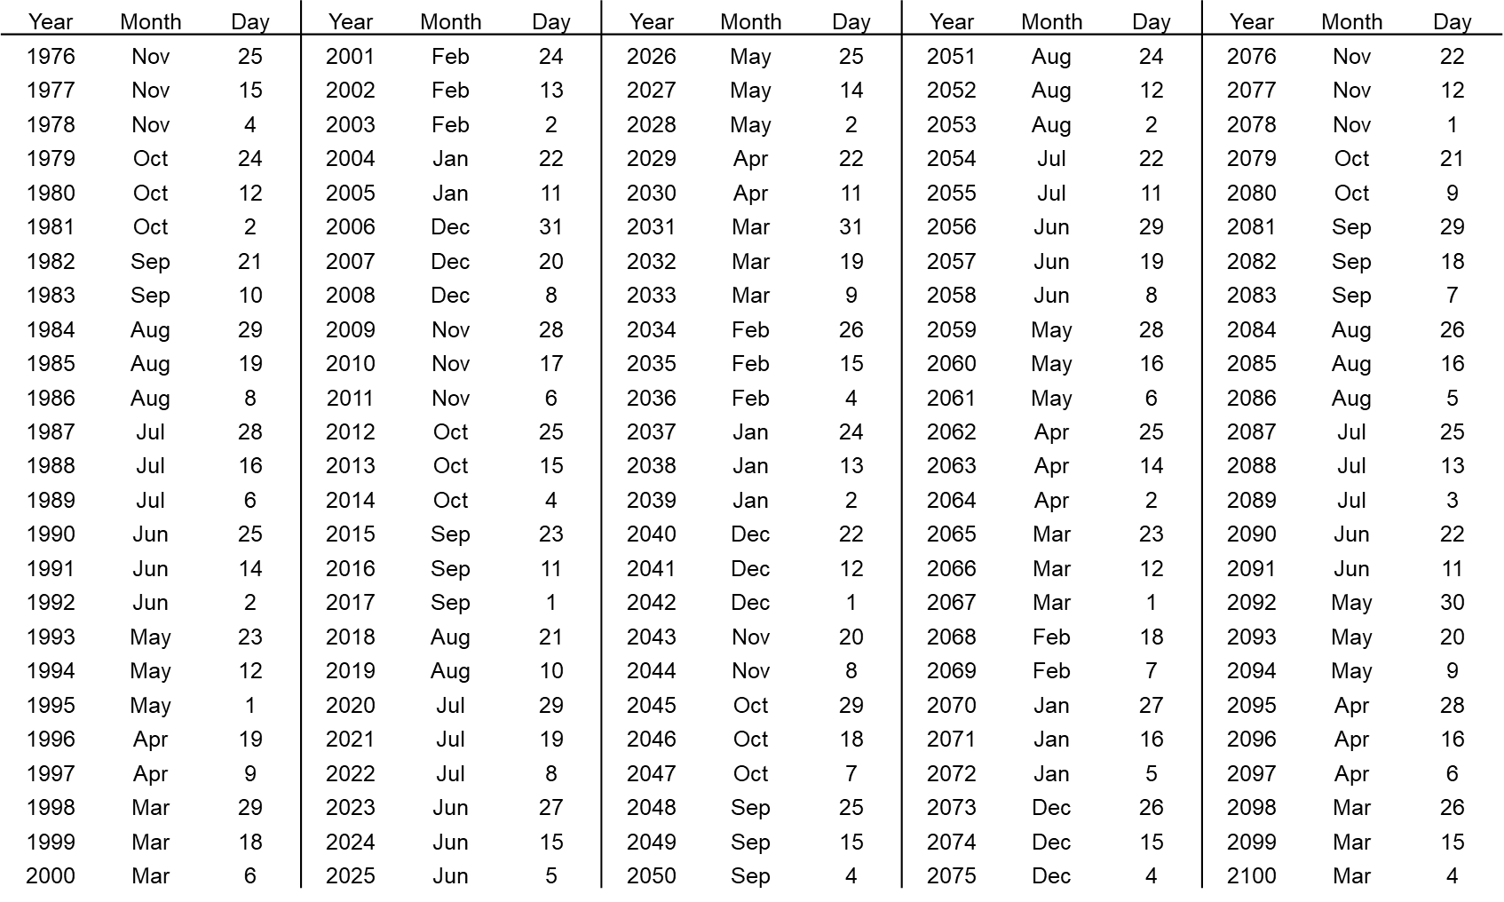

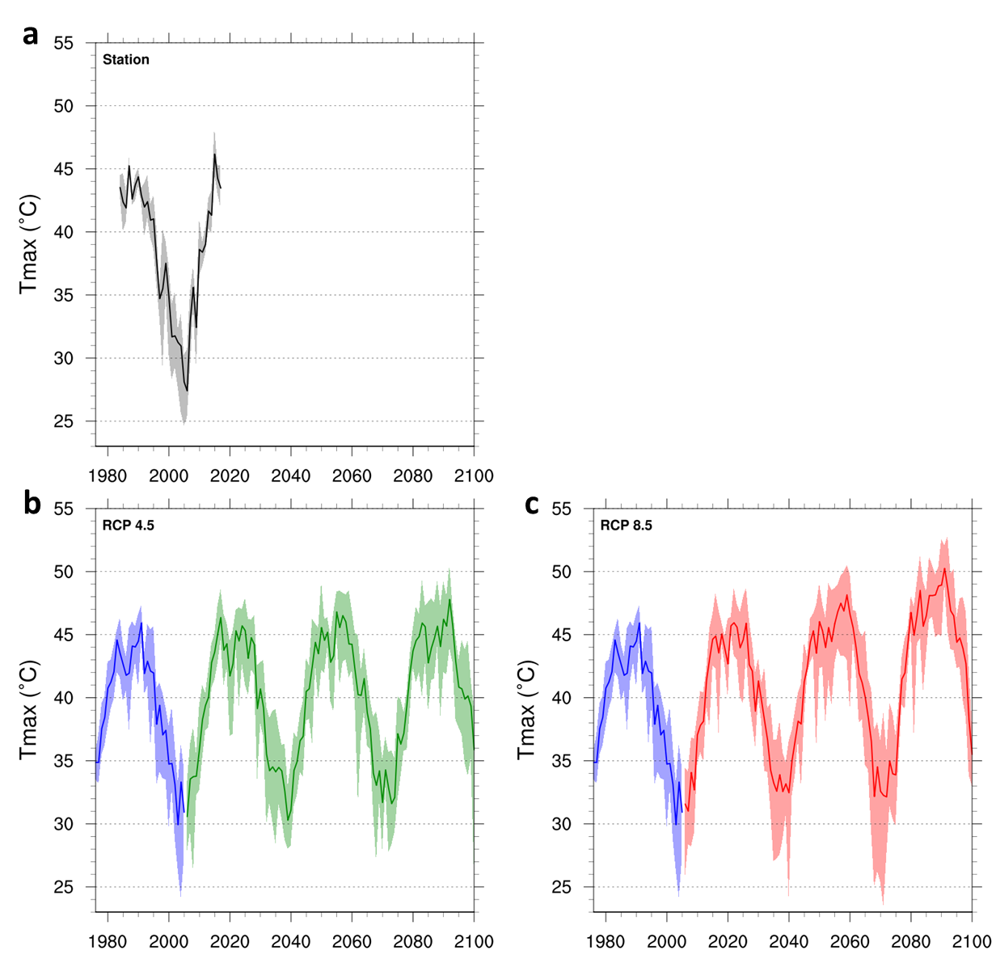
Figure S1 Daily maximum temperature (T_{max}, ºC) during Hajj: (a) T_{max} from station (black, 1984-2017) during Hajj; (b) T_{max} for HIST (blue, 1976-2005) and RCP 4.5 (green, 2006-2100) during Hajj; and (c) T_{max} for HIST (blue, 1976-2005) and RCP 8.5 (red, 2006-2100) during Hajj. In a-c, the thick line is the average of T_{max}; the shading represents the AOGCM ranges during Hajj.

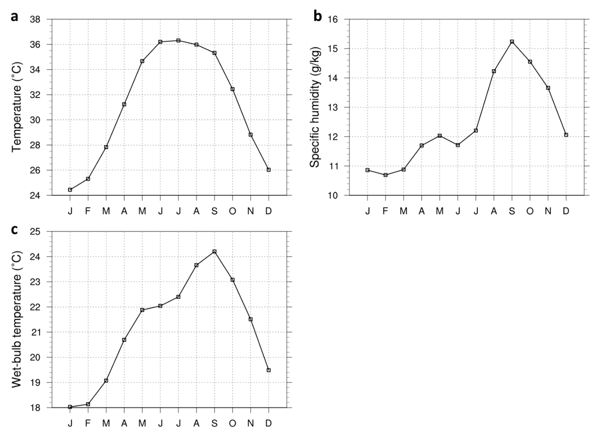
Figure S2 Monthly mean seasonal cycle of surface variables over Mecca: (a) T; (b) specific humidity and (c) TW from the station observations for the 1984-2017.

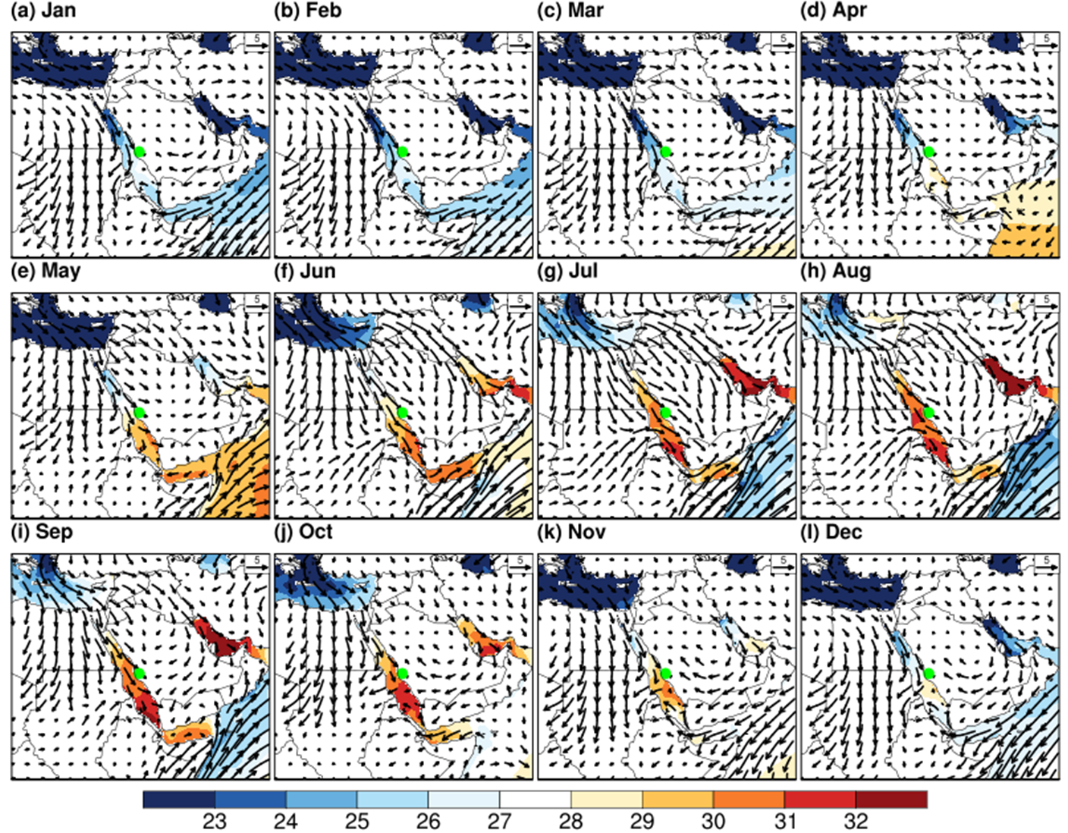
Figure S3 Spatial distribution for sea surface temperature (shading) and surface wind (vector): Mean monthly sea surface temperature (shading, ºC) and surface wind (vector, m/s) from NOAA high resolution OISST version 2 (30) and the ERA-interim reanalysis (31) for the period 1979-2017, respectively. The Hajj/Mecca region is highlighted in green.

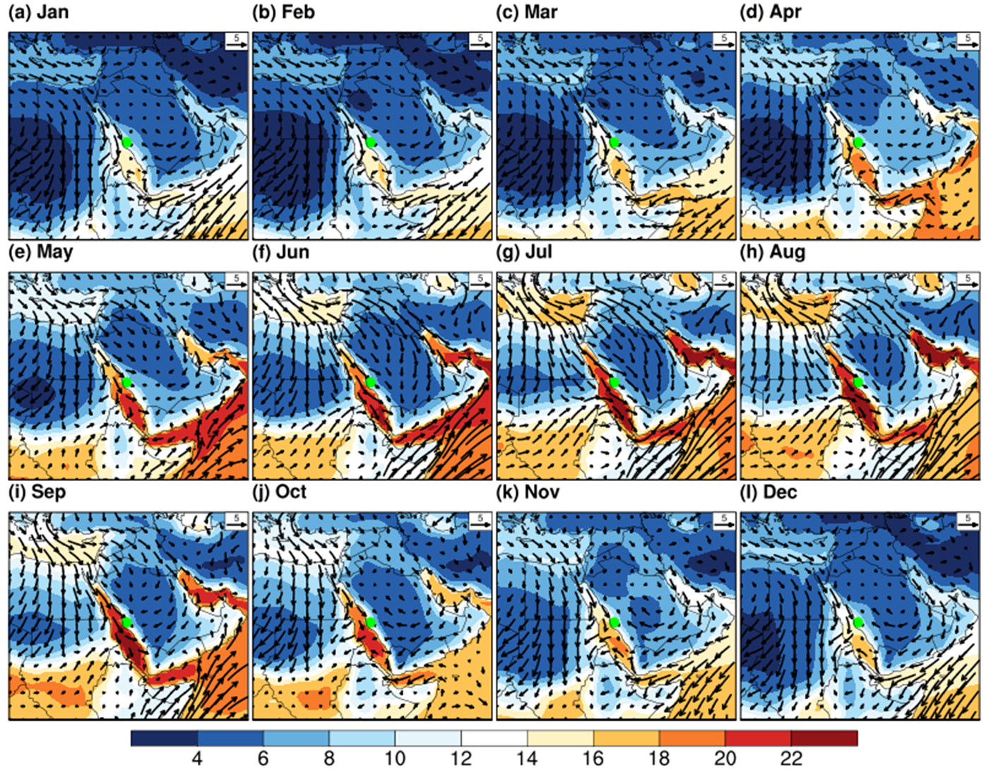
Figure S4 Spatial distribution for surface specific humidity (shading) and surface wind (vector): Mean monthly surface specific humidity (shading, g/kg) and surface wind (vector, m/s) from the ERA-interim reanalysis¹⁵ for the period 1979-2017. The Hajj/Mecca region is highlighted in green.

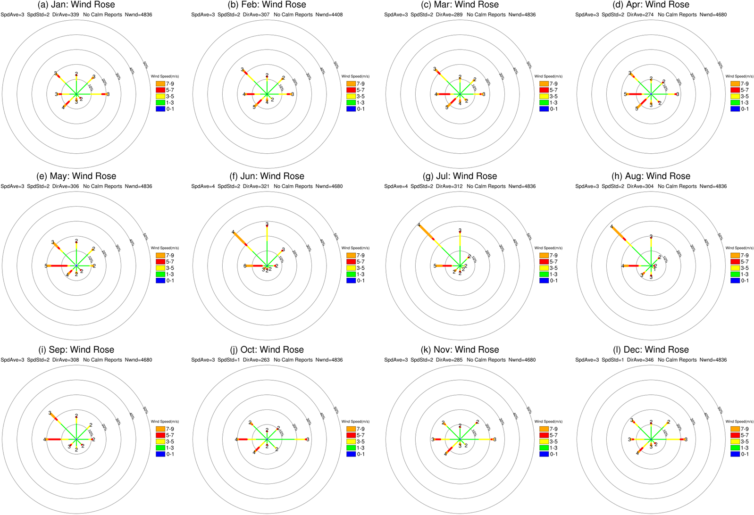
Figure S5 Wind rose diagrams for 6-hourly surface (10m) winds: Monthly wind rose diagrams for 6-hourly surface winds from ERA-interim reanalysis¹⁵ over Mecca for the period 1979-2017. The colors represent mean speed, and the frequency circles are indicated at intervals of 10%.

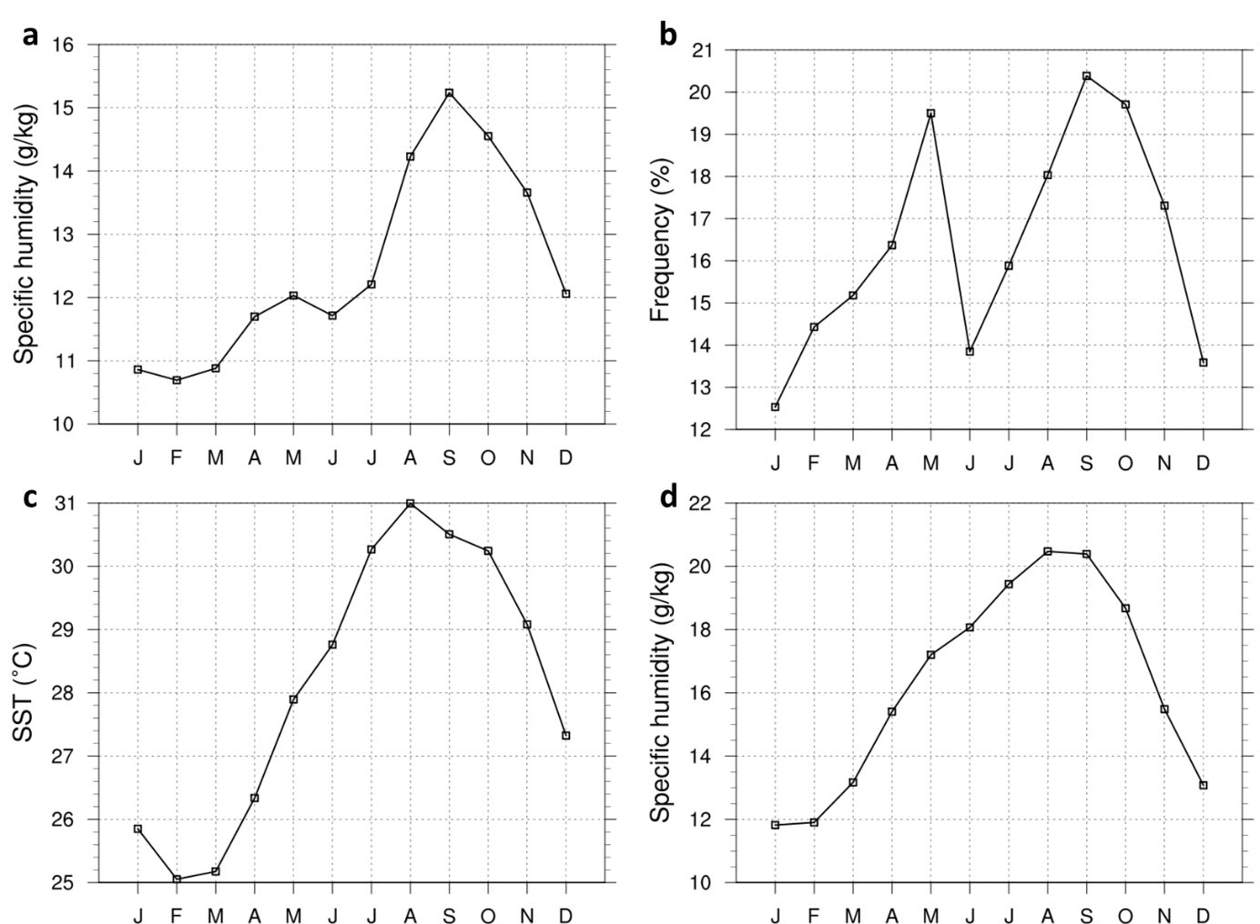
Figure S6 Monthly seasonal climatology: (a) surface specific humidity from Mecca station (1984-2017); (b) frequency of westerly wind in Figure S3; (c) area averaged (21.5ºN~22.5ºN, 38ºE~39ºE) sea surface temperature from NOAA high resolution OISST v2¹⁶ (1982~2017); and (d) Area averaged (21.5ºN~22.5ºN, 38ºE~39ºE) surface specific humidity from ERA-Interim reanalysis¹⁵ (1979-2017).

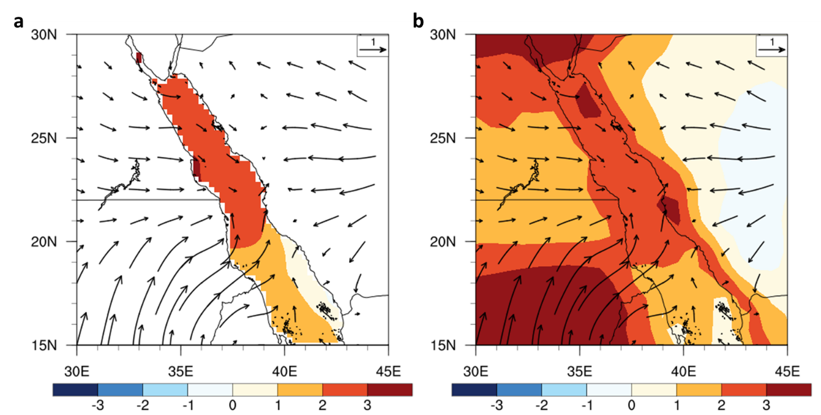
Figure S7 Maps of ERA-Interim reanalysis average a) sea surface temperature seasonal change (August-September minus May-June) (shading) and surface winds (vectors) for the period 1979-2017 and b) surface specific humidity seasonal change and surface winds.

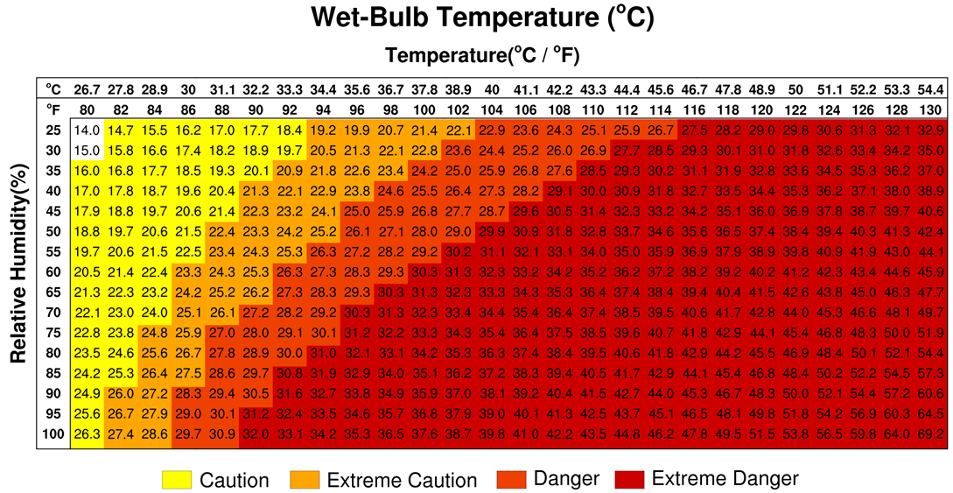
Figure S8 Table of wet-bulb temperature generated from temperature and relative humidity. Background colors indicate categories of heat-stress risk levels from US NWS heat index (3).

